Invention Disclosure Form
Section A: Applicant(s)/Inventor(s) Details

- APPLICANT DETAILS

Name: SR University, Warangal Mobile No. 9849426581

Email: registrar@sru.edu.in Nationality: Indian

Address: Ananthasagar, Hasanparthy(PO), Warangal-506371

- INVENTOR DETAILS( For multiple inventors, copy paste this data and fill)

- First Inventor
Name: Valaboju Harshavardhanu | Mobile No. 9398564035
Email: harshavardhanuvalaboju91@gmail.com | Nationality: Indian
Address: #1-148/1, Narsampet, Warangal Dist-506132
Sign 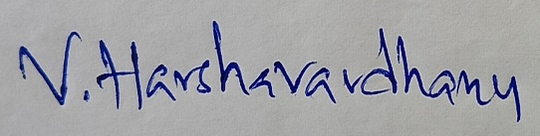

- Second Inventor
Name: Anyam Akshitha | Mobile No. 7673949767
Email: akshithaanyam@gmail.com | Nationality: Indian
Address: #15-4-198, Warangal, Warangal-506371
Sign 

- Third Inventor
Name: Dr. SRIDHAR CHINTALA | Mobile No. 9471503571
Email: dr.sridharchintala@gmail.com | Nationality: Indian
Address: Ananthasagar, Hasanparthy (PO), Warangal-506371
Sign 
IP support services you wish for us to fulfill (Please specify the services needed in the space provided for one of multiple choices or simply write SELECT in block letters next to the service needed):- ( Leave this, don’t fill)
- Patentability Search _______________________________________________________
- Provisional Patent Application – Select
- Non-Provisional Patent Application __________________________________________

3. Point of contact (POC) between Inventors and IP Curate Labs IPR Research Team:
1st Point Of Contact(Leave this as it is)
Name: Dr.Sk. Vaseem Akram Calling: 9010748746
WhatsApp: 9010748746 Email: patent@sru.edu.in

4. Should the first POC be unavailable, we would feel comfortable knowing whom next to talk to:
2nd Point Of Contact:-
Name: Dr. Sk. Vaseem Akram Calling: 9010748746
WhatsApp:9010748746 Email: shaik.vaseemakram@sru.edu.in

5. Have you previously disclosed your idea to anyone? If so, where and how have you revealed said information?( Leave as it is)
Ans.No.

Section B: Your Invention

INVENTION TITLE: Facial Landmark-Based Two-Step Authentication System Using One-Class SVM and Euclidean Verification
B. PROBLEM STATEMENT:
In today’s digital world, where personal smart devices, secure apps, and interconnected systems have became an integral part of our daily life. As our dependence on technology grows, securing access to these devices while preserving user privacy has become a major concern. However, traditional facial recognition methods often depends on cloud-based services, making them vulnerable to security risks and ineffective in offline or low-connectivity environments.
To overcome this growing concern, a solution is needed that provide personalized, secure authentication without dependence on constant connectivity or cloud services. It should be reliable, work offline, resist spoofing attacks, and run efficiently on low-power devices like laptops, embedded systems, and Raspberry Pi.

Detailed Explanation of the Problem:
- Limitations of General-Purpose Face Recognition:
  - Most facial recognition systems are built for multi-user identification, requiring extensive datasets and computational resources.
  - These systems are overly complex for personal use and often unreliable in challenging conditions such as low light, angled views or partial face visibility.
- Privacy and Data Security Concerns:
  - Cloud-based systems require external processing of facial data, raising concerns about privacy, data leaks, and unauthorized surveillance.
  - Users have no transparency or control over how or where their biometric data is stored or used.
- Vulnerability to Spoofing:
  - Conventional systems can often be tricked using printed photos or digital screens.
  - Lack of deeper biometric verification allows attackers to exploit simple image-based methods.
  - There is no layered validation beyond initial face detection in many existing systems.
- Dependence on Internet Connectivity:
  - Many commercial solutions need active network connections for verification or syncing with remote servers.
  - This dependency renders them ineffective in offline or secure environments like military zones, personal labs, or remote offices.
- Need for Lightweight, Real-Time Operation:
  - Heavy deep learning models are difficult to run on edge devices due to processing constraints, yet users require real-time, low-latency access without relying on server responses.
  - Devices like Raspberry Pi and smartphones demand efficiency and energy-saving design.
- EXISTING SOLUTIONS :
- List any known products, or combination of products, currently available to solve the same problem(s). What is the present commercial practice?
The challenge of secure, real-time facial authentication in offline personal devices has been partially approached by existing technologies such as Apple’s Face ID, Android Face Unlock, and cloud-based services like AWS Rekognition and Microsoft Azure Face API. These solutions utilize deep learning and facial feature encoding, often enhanced with infrared sensors for depth detection. While effective for general use, they are primarily designed for multi-user identification and rely heavily on cloud resources for processing, updates, and synchronization. Enterprise-level systems also integrate facial recognition for surveillance and access control, but these are complex and not suited for individual use. Traditional authentication methods like fingerprints, PINs, and passwords remain common, though they lack of biometric sophistication. Most current solutions embed facial recognition into operating systems or utilize third-party biometric APIs, following a cloud-centric model. This introduces privacy concerns, internet dependency, and unnecessary complexity for single-user needs. These systems are not optimized for lightweight, offline, or energy-efficient environments. Consequently, there is a clear need for secure, personal-use facial authentication in commercial offerings that functions privately and offline.
- In what way(s) do the presently available solutions fall short of fully solving the problem?
Despite the availability of facial recognition technology is widely available, most of the current systems still don’t meet the needs of secure, offline, single-user personal authentication due to several critical limitations:
- Lack of Personalization: Commercial facial recognition systems are trained on large, multi-user datasets and are not designed to recognize only one specific user. Their algorithms prioritize generalization over personalization, resulting in unnecessary computational overhead and reduced efficiency for single-user use cases.
- Cloud and Hardware Dependency: Systems like AWS Rekognition or Face ID usually depend on the cloud or special hardware to work. This creates delays, requires internet access, and limits control especially for users who want everything handled on their own device.
- Privacy Risks: Many systems send your facial data to remote servers for processing, which raises significant data privacy issues. Users cannot always verify where or how their biometric data is being stored or used, which is particularly concerning in high-security or personal environments.
- Spoofing Vulnerability: Several face recognition systems can be fooled using static photographs or video replays, especially in the absence of liveness detection or layered verification. Their single-layered approach often fails to verify whether the input is genuine or an Unauthorized access attempt.
- Incompatibility with Edge Devices: Traditional face recognition models are often too heavy to run on small devices like Raspberry Pi. This limits their accessibility in real-time, offline environments where simplicity and speed are essential.
- Conduct key word searches using Google and list relevant prior art material found?

Offline facial recognition with One-Class SVM
Facial authentication using landmarks and Euclidean metrics
Single-user facial verification system
MediaPipe FaceMesh authentication models

D.DESCRIPTION OF PROPOSED INVENTION:
The proposed system offers fast, secure, and private facial authentication tailored for a single user. It operates through fully offline using facial landmark analysis combined with One-Class SVM and Euclidean distance verification. Designed for lightweight, real-time performance, the solution runs efficiently on edge devices like laptops, Raspberry Pi, or mobile hardware without relying on the internet or GPU acceleration ensuring strong data privacy and reliable personal access control.
Working Process:

1. The process begins with live facial image capture using a regular webcam or mobile phone camera. This occurs in real-time, without saving or transmitting any images, ensuring total privacy and data security. Once a face is detected, the system initiates feature extraction and verification procedures instantly.

2. The system uses MediaPipe FaceMesh to detect 468 facial landmarks, capturing precise geometric features of the user’s face. Each landmark consists of x and y coordinates, resulting in a 936-element vector that uniquely represents the user’s facial structure in that moment.

3. To ensure consistent recognition across different lighting conditions, face angles, or distances from the camera, the landmark vectors are normalized. This process aligns the data to a uniform scale, reducing distortion from pose variation and improving reliability during authentication.

4. If the One-Class Support Vector Machine (SVM) produces a positive result, the system proceeds to a second verification phase. It computes the Euclidean distance between the input vector and pre-stored landmark vectors of the authorized user. If the calculated distance falls within an acceptable threshold, the system confirms the user's identity with high confidence.

5. Access is granted only if both the SVM and Euclidean checks are successful. In this case, the system returns an “Unlocked” status. If either condition fails, access remains “Locked.” If no face is detected during the initial stage, the system provides a user prompt such as “No face found,” ensuring clear feedback and usability throughout the process.

Implementation:

- Hardware Setup:
  - The system runs on low-cost, widely available devices such as laptops or Raspberry Pi boards with a basic camera module.
  - It does not require high-performance GPUs, making it suitable for individual users and embedded systems.
- Software Stack:
  - MediaPipe is used for detecting facial landmarks in real time.
  - OpenCV handles camera input and user interface interactions.
  - Scikit-learn is used to train and run the One-Class SVM model.
  - NumPy supports numerical operations and vector processing.
- Model Training and Storage:
  - The model is trained using only the authorized user’s facial landmark data collected in various lighting and angle conditions.
  - All data and the trained model are stored locally on the user’s device to ensure complete privacy and offline functionality.
- Accuracy and Security:
  - Internal testing shows over 95% accuracy for recognizing the authorized user.
  - A dual-layer system (One-Class SVM + Euclidean verification) improves resistance to spoofing attacks and enhances real-world reliability.
This lightweight facial authentication system ensures real-time access, offline operation, and strong privacy protection ideal for personal and secure use cases on edge devices.

E.NOVELTY:
The novelty of the "Facial Landmark-Based Two-Step Authentication System Using One-Class SVM and Euclidean Verification" lies in its ability to perform secure, real-time facial authentication for a single user completely offline using lightweight, explainable AI.
How it stands out:
1. The system performs instant facial authentication without internet access, unlike traditional cloud-based systems. All processing takes place locally, ensuring zero data transmission and complete user privacy.
2. Designed for single-user use, the system eliminates multi-user complexity. This personalized approach reduces training time and improves authentication speed for private settings like home devices or personal digital locks.
3. A dual-layer verification model enhances security by combining One-Class SVM (trained only on the authorized user) with Euclidean distance checks for facial geometry, ensuring accurate and spoof-resistant recognition.
4. The system uses direct facial landmark coordinates, making it transparent, explainable, and easy to debug unlike black-box neural networks used in most commercial systems.
5. It is optimized for edge devices and runs smoothly on hardware like Raspberry Pi or standard laptops without the need for high memory or GPU, making it cost-effective and portable.
6. No facial images are stored or uploaded. All operations remain fully on-device, providing a privacy-first solution that protects biometric data from misuse or surveillance.

F. COMPARISON:

Previous Solutions: Facial Recognition and Authentication Technologies
- Traditional Methods (Passwords, PINs, and Fingerprints):
  - How it worked: Users unlocked devices using typed passwords or fingerprint scans.
  - Limitations:
    - Require physical interaction with the device
    - Fingerprints and PINs can be shared, stolen, or duplicated.
    - Lacks contextual or environmental awareness
    - Not adaptable to dynamic conditions or personal environments.
- Mobile Face Unlock (Android Face Unlock, Apple Face ID):
  - How it worked: Used infrared sensors or front-facing cameras to detect and recognize user faces using neural network-based classifiers embedded in the mobile operating system
  - Limitations:
    - Generalized for multi-user environments.
    - Partially cloud-dependent for firmware updates or improved recognition.
    - Vulnerable to spoofing attacks using photographs or video playbacks
    - Heavily hardware-restricted
- Cloud-Based APIs (AWS Rekognition, Microsoft Face API, etc.):
  - How it worked: Captured facial images are uploaded to cloud platforms where recognition and verification take place using large-scale, pre-trained deep learning models.
  - Limitations:
    - High dependency on stable internet connectivity.
    - Latency due to cloud processing and data transfer.
    - Ongoing operational costs and subscription fees.
    - Data privacy concerns.

Proposed Solution: Facial Landmark-Based Personal Authentication System Using One-Class SVM and Euclidean Verification.
- How it Works:
  - Facial Landmark Extraction: The system captures real-time facial input via webcam or mobile camera and extracts 468 2D facial landmarks using MediaPipe FaceMesh.
  - Offline Machine Learning Verification: A One-Class SVM trained exclusively on the authorized user’s facial landmark vectors checks for user validity.
  - Mathematical Proximity Verification: Upon passing the SVM step, the system calculates Euclidean distance between the input vector and stored landmark data for further confirmation.
  - Real-Time Execution: The entire process takes place on the local device without any network or cloud dependency.
- Key Features:
  - Real-Time Processing: Authentication is completed within seconds, providing immediate feedback to the user.
  - Fully Offline: The system runs on edge hardware like laptops or Raspberry Pi, suitable for disconnected or remote settings.
  - Lightweight and Cost-Effective: No need for GPUs, servers, or external dependencies enabling implementation in minimal computing environments.
  - Privacy-Centric: No facial images are stored or transmitted; the system works entirely with numerical vectors, ensuring confidentiality.
  - Single-User Focused: Optimized for one-person authentication, ideal for personal systems rather than multi-user platforms.
- Advantages Over Previous Solutions:
  - Stronger Anti-Spoofing Capabilities: The two-step verification pipeline makes it significantly harder to bypass using static images or videos.
  - Faster Performance: Eliminates cloud latency and accelerates authentication response time through local computation.
  - Enhanced Security and Transparency: No hidden processes or black-box embeddings the landmark vectors and decisions are traceable and explainable.
  - Hardware Agnostic: Compatible with commonly available low-cost hardware, making it accessible for a wide range of users and devices.
- Example Workflow:
  - A user attempts to unlock their device by looking into a webcam.
  - The system extracts landmark data from the user’s facial features.
  - The One-Class SVM model checks if the pattern belongs to the registered user.
  - If validated, the Euclidean distance module measures vector similarity to the stored templates.
  - If both steps pass, the device is “Unlocked”; otherwise, it remains “Locked” or signals “No face found.”
- This proposed system directly addresses the limitations of existing face authentication technologies by combining the strengths of real-time local computation, privacy preservation, and robust anomaly detection. It empowers users with secure, personal, and independent access control that functions without reliance on cloud infrastructure or external biometric databases.
- This invention is akin to having a smart, private biometric key that works anytime, anywhere designed specifically for a single user, processed on the user’s own device, and secured against external threats or misuse. It’s fast, accurate, reliable, and ready for real-world offline deployment.

G. ADDITIONAL INFORMATION:
This system is a privacy-first, AI-powered facial authentication solution that provides secure, real-time access control using only the facial landmarks of a single authorized user. Designed to work entirely offline, it ensures fast and accurate identity verification without storing or transmitting facial images.

How It Works
- Image Capture:
  - A camera either embedded in a laptop, smartphone, or external webcam captures the face of the user in real time.
- Facial Landmark Extraction and Normalization:
  - The system uses MediaPipe FaceMesh to extract 468 2D facial landmarks, which are then flattened into a 936-dimensional feature vector.
  - Landmark vectors are normalized to account for differences in scale, position, or head orientation.
- Machine Learning-Based User Validation:
  - A One-Class SVM model determines if the input vector matches the authorized user; if classified as positive (+1), the verification process continues.
- Euclidean Distance Verification:
  - The system calculates the Euclidean distance between the current facial vector and stored vectors; if it falls within an acceptable threshold, the user is authenticated.
- Access Control Decision:
  - If both the SVM and Euclidean checks succeed, access is granted; otherwise, access is denied, and if no face is detected, an alert is issued.

Key Technologies Used:
- MediaPipe FaceMesh:
  - A robust framework for real-time, high-fidelity facial landmark detection.
- OpenCV (Python):
  - Used for capturing images, processing frames, and interfacing with the system's user interface.
- One-Class SVM(Scikit-learn):
  - A machine learning algorithm used for anomaly detection based on a single-user training set.

Benefits:
- Enhanced Security:
  - Dual verification prevents spoofing and unauthorized access.
- Privacy-Preserving:
  - Reduces the need for manual inspections and minimizes unnecessary use of pesticides.
- Accessibility:
  - Works with landmark data only no facial images stored.
- Offline Compatibility:
  - No internet or cloud services required ideal for sensitive environments.
- Low Resource Requirements:
  - Can run on low-power edge devices, making it cost-effective and widely deployable.

Applications:
- Laptop / PC Unlocking:
  - Replace traditional passwords with secure facial landmark authentication for personal devices.
- Encrypted Folder or App Access:
  - Enable privacy-controlled access to sensitive data and personal applications.
- Smart Door Lock Systems:
  - Use facial landmark recognition to grant entry to homes, labs, or office spaces without physical keys or cards.
- Vehicle Ignition Control:
  - Ensure only the authorized driver can start the vehicle, preventing theft or misuse.

Facial recognition is evolving beyond mass surveillance and multi-user detection. This invention empowers individuals with a fast, private, offline, and trustworthy authentication mechanism. Whether used for protecting personal devices, smart access points, or sensitive data, the system delivers a lightweight and intelligent biometric layer with full control in the user’s hands.

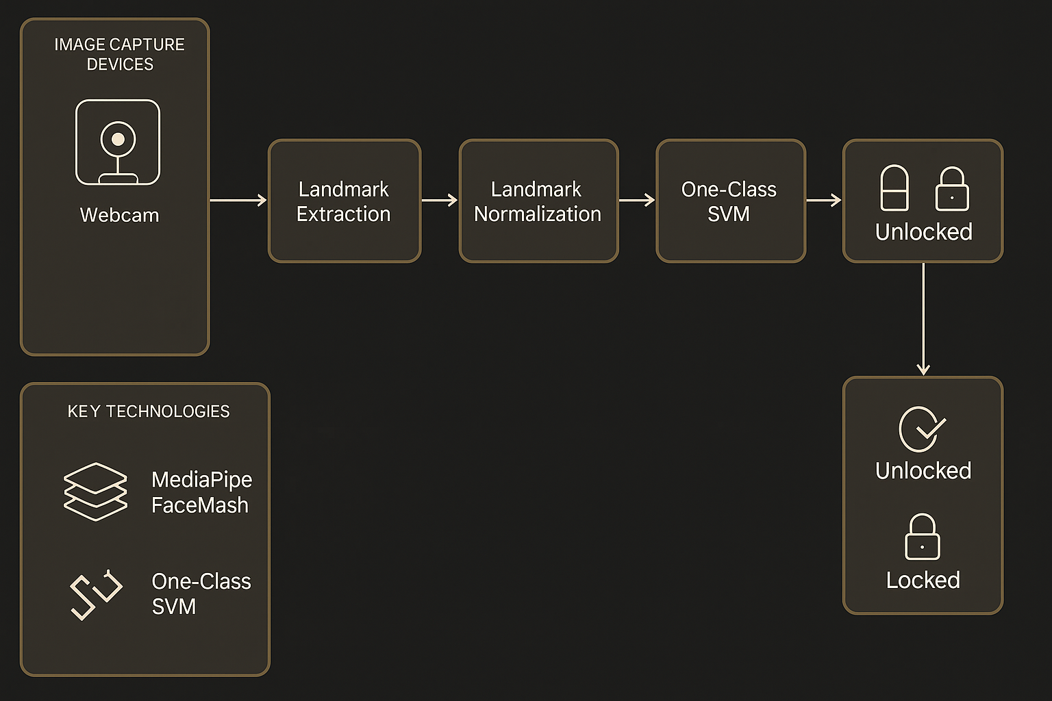
Block Diagram of the Proposed System

